Table of Contents

1. Repository Information

1.1. Description

2. Images

3. Usage Instructions

4. Build Instructions

5. Hardware

5.1. modular_device_base_5x3

5.1.1. Repository Information

5.1.2. Images

5.1.3. Schematic

5.1.4. Gerbers

5.1.5. Bill of Materials

5.1.6. Supplemental Documentation

5.2. modular_device_enclosure

5.2.1. Repository Information

5.2.2. Assembly Instructions

5.2.3. Bill of Materials

5.2.4. DXF Files

5.3. modular_device_remote_switch

5.3.1. Repository Information

5.3.2. Images

5.3.3. Schematic

5.3.4. Bill of Materials

5.3.5. Supplemental Documentation

5.4. stepper_controller_5x3

5.4.1. Repository Information

5.4.2. Images

5.4.3. Schematic

5.4.4. Gerbers

5.4.5. Bill of Materials

5.4.6. Supplemental Documentation

6. Firmware

6.1. SpinningPlatformController

6.1.1. Library Information

6.1.2. API NAMES

6.1.3. API GENERAL

6.1.4. Ancestors

6.1.5. Clients

6.1.6. Devices

6.1.7. More Detailed Modular Device Information

6.1.8. Installation Instructions

# Repository Information

1. Name
   1. spinning_platform_controller
2. Version
   1. 1.0
3. License
   1. BSD, Open-Source Hardware
4. URL
   1. <https://github.com/janelia-modular-devices/spinning_platform_controller.git>
5. Author
   1. Peter Polidoro
6. Email
   1. peterpolidoro@gmail.com

## Description

This device controls the rotations of the spinning platform.

# Images

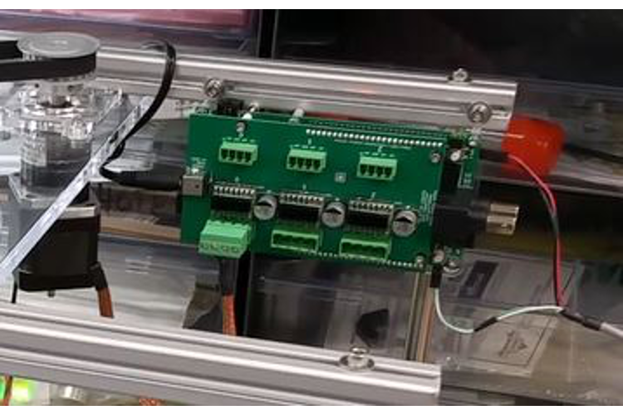

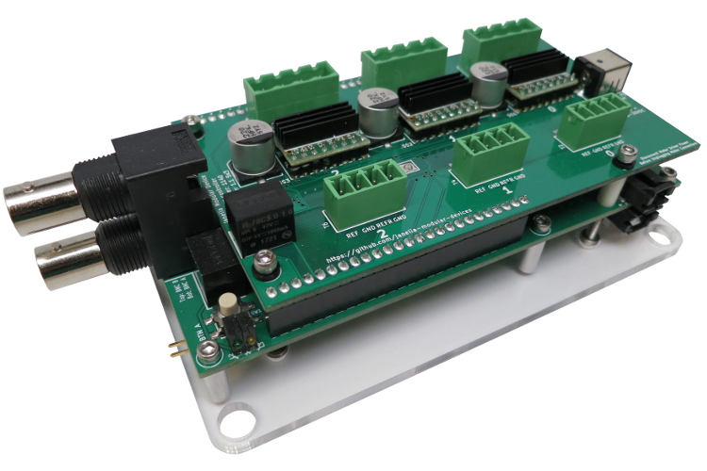

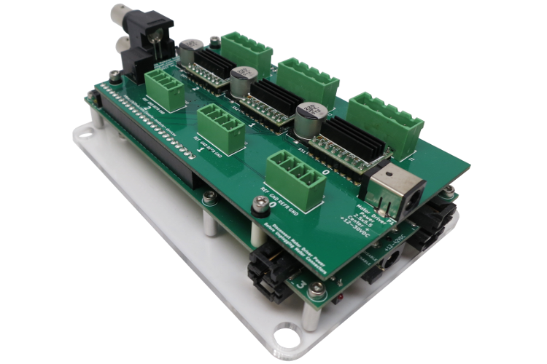

# Usage Instructions

* The switches control the rotations of the spinning platform.
* Clicking the switch connected to BTN A of the controller causes the target platform position to increment by one rotation in the positive direction.
* Clicking the switch connected to BTN B of the controller causes the target platform position to increment by one rotation in the negative direction.
* The platform spins until its position equals the target position and then it stops, waiting indefinitely for more user input.
* For example, if the platform is stopped and the user presses the switch connected to BTN A five times and then quickly presses the switch connected to BTN B two times, then the platform will rotate three full revolutions in the positive direction. (target position = 5 - 2 = 3). If the user waits until the platform has rotated three times until it stops and then presses the switch connected to BTN B three times, the platform will rotate three times in the negative direction and end up where it started originally.

# Build Instructions

* This controller is made from a single 5x3 form factor modular device.
* This device consists of two pcbs, the (modular_device_base_5x3) and the (stepper_controller_5x3).
* In addition to the two pcbs, there is one acrylic mounting plate (modular_device_enclosure 5x3 enclosure_bottom), and two switches (modular_device_remote_switch).
* Send the zip files containing the gerbers for each of the two pcbs to your favorite pcb manufacturer for fabrication.
* Using the bill of materials and vendor parts lists order the parts necessary for construction for the two pcbs, the mounting plate, and the two switches.
* Assemble each of the pcbs using the assembly instructions provided for each.
* Use the dxf file for the enclosure_bottom to cut the mounting plate from the acrylic sheet using a laser cutter or send the dxf to a laser cutting service for fabrication.
* Assemble the two remote switches using the assembly instructions, cutting the cables to the length necessary for the specific setup.
* Connect the four stepper motor wires to a 4 position 0.2 inch terminal block plug connector according to the following table. Then connect that plug into T1 (motor 0) on the stepper controller pcb.

| Stepper Motor | Stepper Controller | Terminal Block Plug Connector |
| --- | --- | --- |
| BLACK | MOTOR 0 A+ | 4 |
| GREEN | MOTOR 0 A- | 3 |
| RED | MOTOR 0 B+ | 2 |
| BLUE | MOTOR 0 B- | 1 |

# Hardware

## modular_device_base_5x3

### Repository Information

1. Name
   1. modular_device_base_5x3
2. Version
   1. 1.2
3. License
   1. Open-Source Hardware
4. URL
   1. <https://github.com/janelia-kicad/modular_device_base_5x3>
5. Author
   1. Peter Polidoro
6. Email
   1. peterpolidoro@gmail.com
7. Description

This board is the base of 5x3 format modular devices. It is a breakout board for the microprocessor, with connections for power, communication, and top boards.

### Images

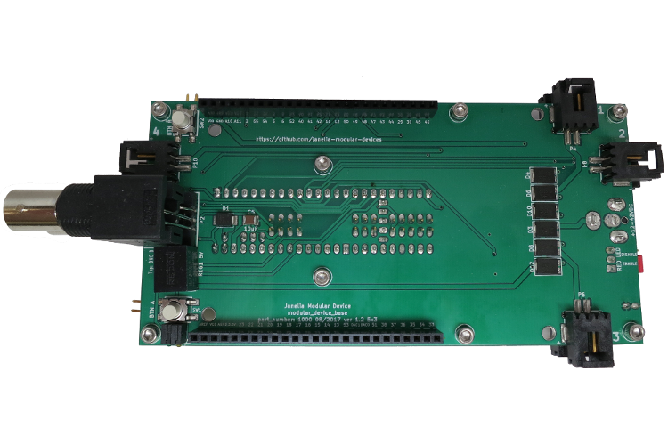

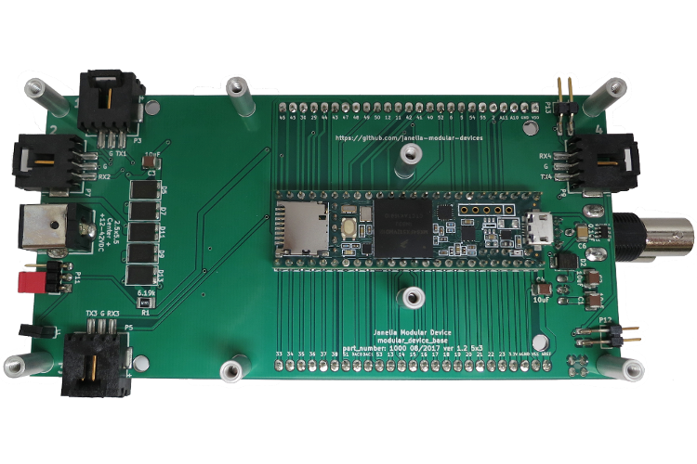

### Schematic

[./hardware/modular_device_base_5x3/schematic/modular_device_base_5x3.pdf](README.odt/hardware/modular_device_base_5x3/schematic/modular_device_base_5x3.pdf)

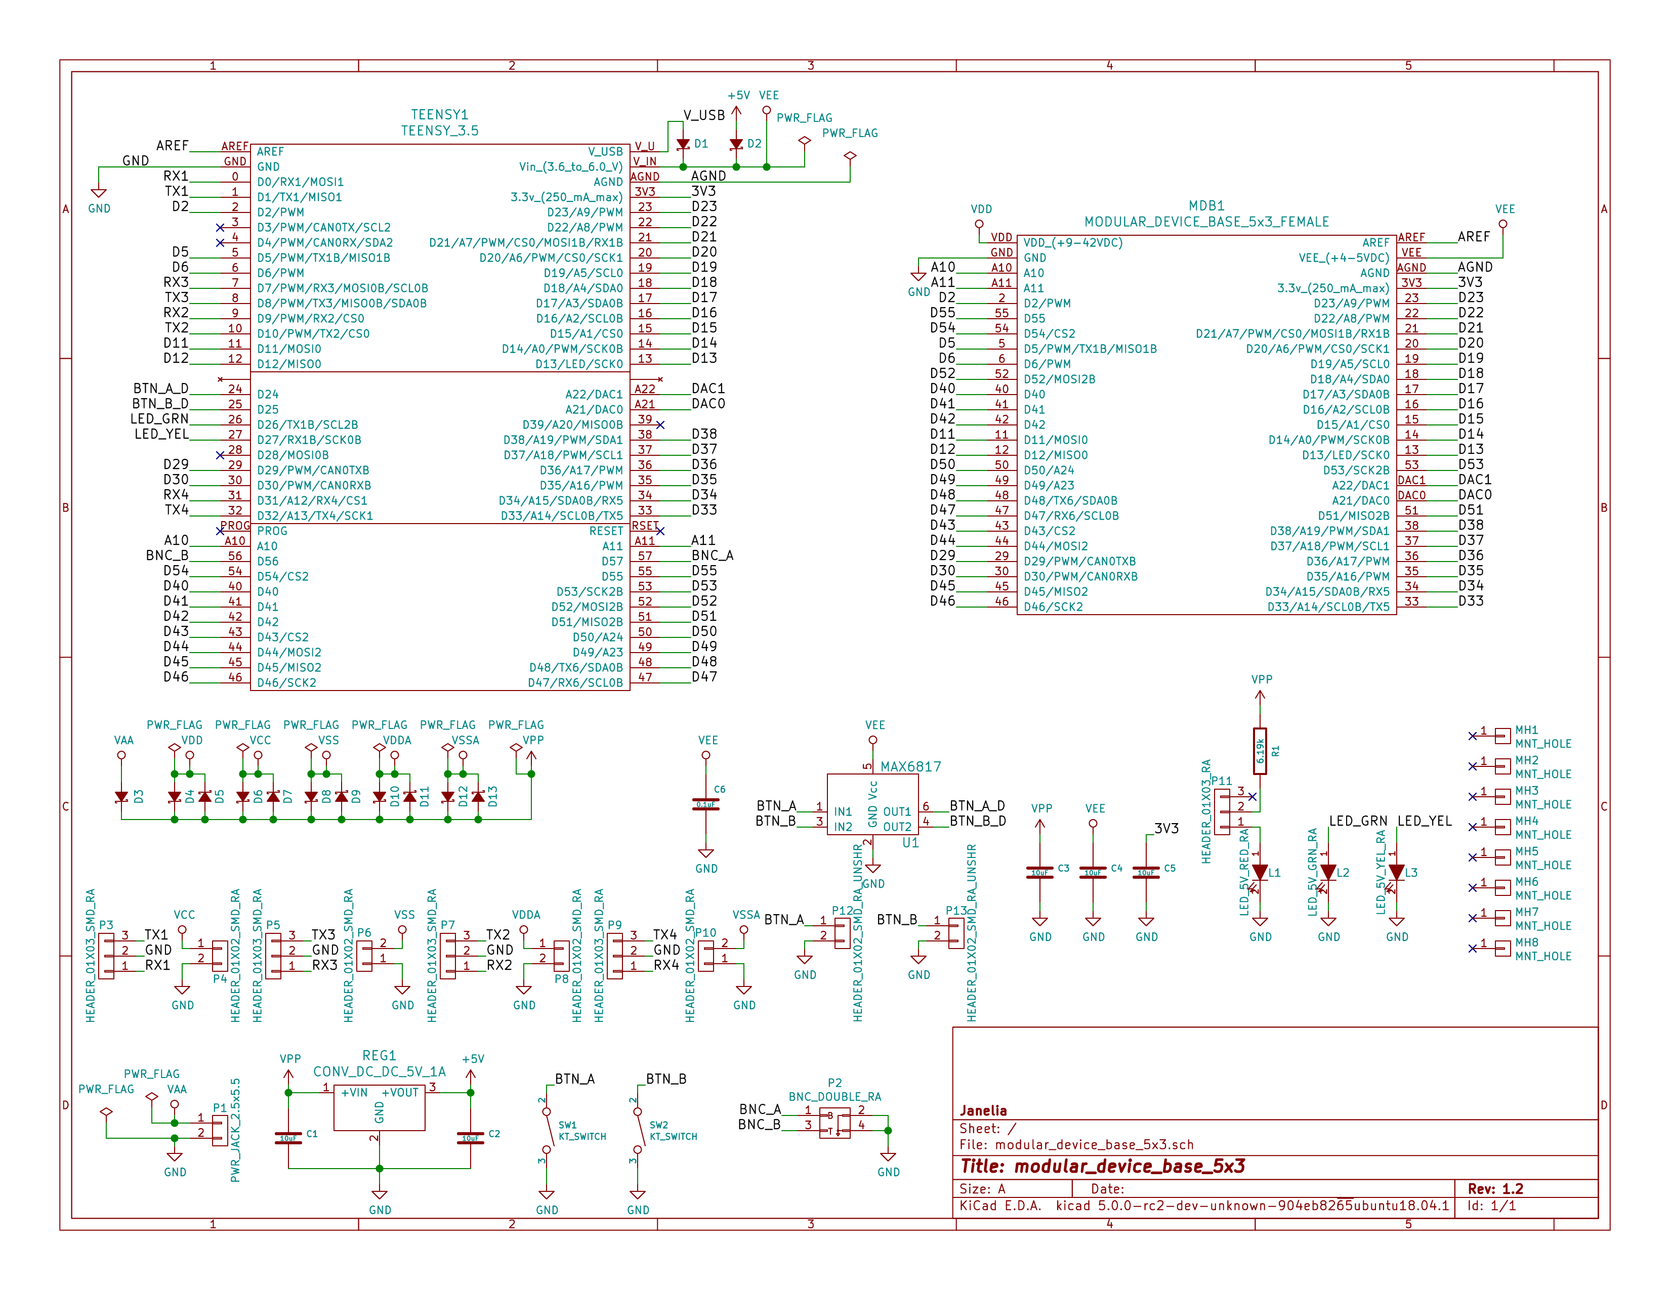

### Gerbers

Send gerbers zip file to your favorite PCB manufacturer for fabrication.

[./hardware/modular_device_base_5x3/gerbers/modular_device_base_5x3_v1.2.zip](README.odt/hardware/modular_device_base_5x3/gerbers/modular_device_base_5x3_v1.2.zip)

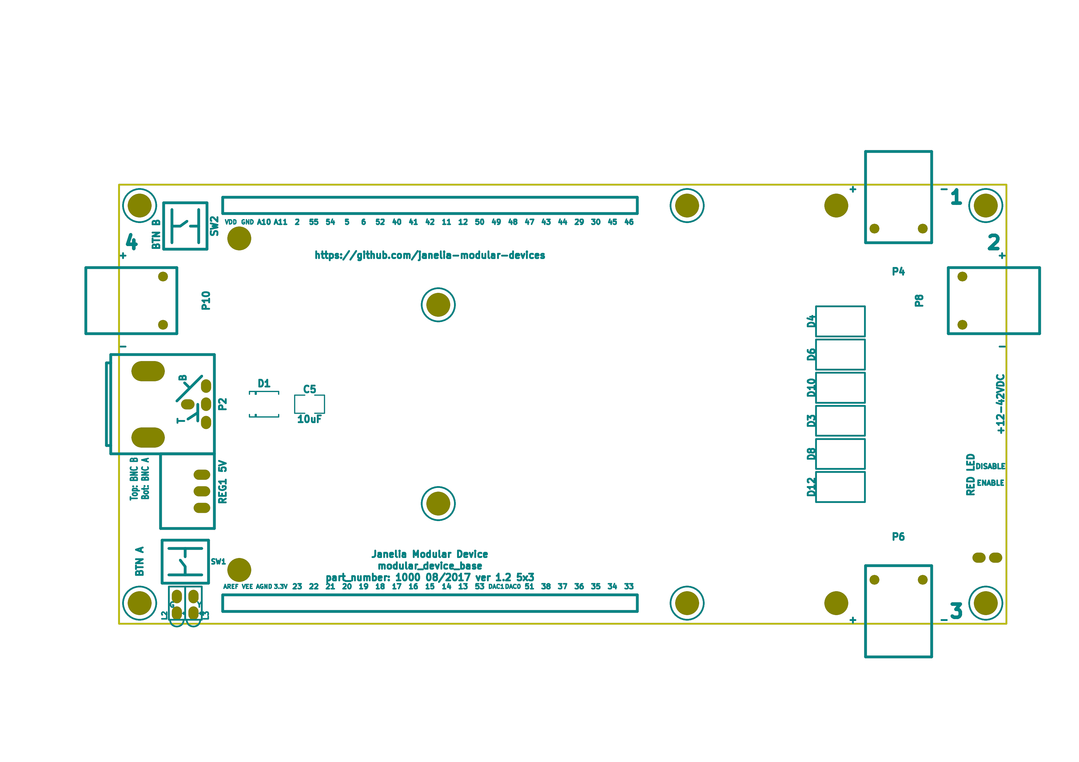

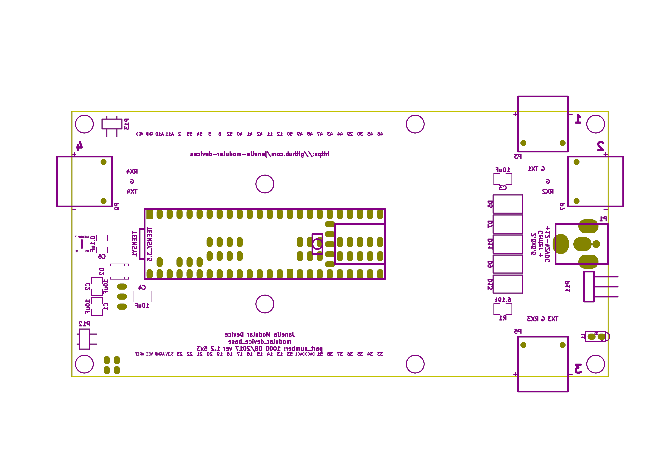

### Bill of Materials

1. PCB Parts

| Item | Reference(s) | Quantity | PartNumber | Vendor | Description |
| --- | --- | --- | --- | --- | --- |
| 1 | C1 C2 C3 C4 C5 | 5 | 445-4536-1-ND | digikey | CAP CER 10UF 50V 10% X7S 1210 |
| 2 | C6 | 1 | 399-13229-1-ND | digikey | CAP CER 0.1UF 100V X7R 1210 |
| 3 | D1 D2 | 2 | LSM115JE3/TR13CT-ND | digikey | DIODE SCHOTTKY 15V 1A DO214BA |
| 4 | D10 D11 D12 D13 D3 D4 D5 D6 D7 D8 D9 | 11 | 568-11697-1-ND | digikey | DIODE SCHOTTKY 45V 10A CFP15 |
| 5 | L1 | 1 | 350-1712-ND | digikey | LED 2MM 5V RT ANGLE RED PCMNT |
| 6 | L2 | 1 | 350-1717-ND | digikey | LED 2MM 5V RT ANGLE GREEN PCMNT |
| 7 | L3 | 1 | 350-1719-ND | digikey | LED 2MM 5V RT ANGLE YELLOW PCMNT |
| 8 | MDB1 | 2 | S7058-ND | digikey | 25 Position Header Through Hole Female Socket |
| 9 | MH1 MH2 MH3 MH4 MH5 MH6 MH7 MH8 | 8 | 36-2027-ND | digikey | Round Standoff Threaded 4-40 Aluminum 0.500in 0.187in |
| 10 | P1 | 1 | CP-063BH-ND | digikey | CONN PWR JACK DC 2.5X5.5 8A T/H |
| 11 | P10 P4 P6 P8 | 4 | A100903CT-ND | digikey | CONN HEADER 2POS R/A SMD GOLD |
| 12 | P11 | 1 | 732-5336-ND | digikey | CONN HEADER 3 POS RA 2.54 |
| 13 | P12 P13 | 2 | SAM10781-ND | digikey | CONN HEADER 2POS .100in SNGL SMD |
| 14 | P2 | 1 | ACX1655-ND | digikey | CONN BNC JACK R/A 75 OHM PCB |
| 15 | P3 P5 P7 P9 | 4 | A100890CT-ND | digikey | CONN HEADER 3POS R/A SMD GOLD |
| 16 | R1 | 1 | P6.19KAACT-ND | digikey | RES SMD 6.19K OHM 1% 1/2W 1210 |
| 17 | REG1 | 1 | 945-1395-5-ND | digikey | CONV DC/DC 1A 5V OUT SIP VERT |
| 18 | SW1 SW2 | 2 | CKN1860CT-ND | digikey | SWITCH TACTILE SPST-NO 1VA 32V |
| 19 | TEENSY1 | 1 | 1568-1443-ND | digikey | TEENSY 3.5 |
| 20 | U1 | 1 | MAX6817EUT+TCT-ND | digikey | IC DEBOUNCER SWITCH DUAL SOT23-6 |

1. Supplemental Parts

| Item | Quantity | PartNumber | Vendor | Description |
| --- | --- | --- | --- | --- |
| 1 | 1 | 62-1187-ND | digikey | AC/DC DESKTOP ADAPTER 24V 90W |
| 2 | 1 | 993-1037-ND | digikey | CORD 3COND NEMA PLUG 320-C5 |
| 3 | 2 | A106625CT-ND | digikey | 14 Positions Header Unshrouded Breakaway Connector 0.100in 2 row SMD |
| 4 | 3 | S1011EC-24-ND | digikey | 14 Positions Header Unshrouded Breakaway Connector 0.100in 1 row Through |
| 5 | 1 | S9001-ND | digikey | CONN JUMPER SHORTING GOLD FLASH |
| 6 | 1 | AE10342-ND | digikey | CABLE USB-A TO MICRO USB-B 2M |
| 7 | 2 | 492-1077-ND | digikey | ROUND SPACER 4 NYLON 7/16in |

1. Vendor Parts Lists

[./hardware/modular_device_base_5x3/bom/digikey_parts.csv](README.odt/hardware/modular_device_base_5x3/bom/digikey_parts.csv)

[./hardware/modular_device_base_5x3/bom/supplemental_digikey_parts.csv](README.odt/hardware/modular_device_base_5x3/bom/supplemental_digikey_parts.csv)

### Supplemental Documentation

1. Assembly Instructions
   * Cut the bottom trace on the Teensy board that connects the 5V pads according to these instructions <https://www.pjrc.com/teensy/external_power.html>.
   * Solder through hole header pins into every Teensy 0.1 inch header hole.
   * Solder surface mount header pins onto the bottom of the Teensy making sure they are properly aligned.
   * Solder surface mount and through hole components onto the pcb.
   * Solder the Teensy into the pcb making sure it is properly aligned.
   * Connect header jumper to RED LED enable pins.

## modular_device_enclosure

### Repository Information

1. Name
   1. modular_device_enclosure
2. License
   1. Open-Source Hardware
3. URL
   1. <https://github.com/janelia-modular-devices/modular_device_enclosure>
4. Author
   1. Peter Polidoro
5. Email
   1. peterpolidoro@gmail.com
6. Description

This repository contains the files for constructing enclosures for modular devices.

### Assembly Instructions

* Count modular devices of each form factor for a particular setup and choose the appropriate dxf file.
* Choose appropriate size of 0.125 inch thick acrylic sheet and cut out dxf file using a laser cutter.
* Press captive nuts into each of the small mounting holes.
* Insert one 0.375 inch cap screw into each hole on the modular device base pcb marked with a white circle and screw a round threaded standoff onto the other side.
* Align header pins of the top pcb with the sockets of the modular device base and press the top pcb onto the base until it is firmly seated.
* On the 5x3 form factor modular devices, place one of the round unthreaded spacers between the top pcb and the base pcb at the two mounting holes furthest from the header pins.
* Place one nylon washer onto each of the 1.25 inch cap screws and insert one of the screws with a washer into each of the mounting holes on the top pcb marked with a white circle.
* Align the 1.25 inch cap screws with the captive nuts pressed into the acrylic and screw each one in firmly, but not so tightly as to bend the acrylic.

### Bill of Materials

1. Enclosure Parts

[./hardware/modular_device_enclosure/bom/bom.org](README.odt/hardware/modular_device_enclosure/bom/bom.org)

1. Supplemental Parts

[./hardware/modular_device_enclosure/bom/supplemental_bom.org](README.odt/hardware/modular_device_enclosure/bom/supplemental_bom.org)

1. Vendor Parts Lists

[./hardware/modular_device_enclosure/bom/digikey_parts.org](README.odt/hardware/modular_device_enclosure/bom/digikey_parts.org)

[./hardware/modular_device_enclosure/bom/mcmaster_parts.org](README.odt/hardware/modular_device_enclosure/bom/mcmaster_parts.org)

### DXF Files

1. Single Modular Device
   1. 3x2 Form Factor

[./hardware/modular_device_enclosure/3x2/dxf/enclosure_bottom.dxf](README.odt/hardware/modular_device_enclosure/3x2/dxf/enclosure_bottom.dxf)

* 1. 5x3 Form Factor

[./hardware/modular_device_enclosure/5x3/dxf/enclosure_bottom.dxf](README.odt/hardware/modular_device_enclosure/5x3/dxf/enclosure_bottom.dxf)

1. Multiple Modular Devices
   1. 3x2 Form Factor

[./hardware/modular_device_enclosure/multiple/3x2x2.dxf](README.odt/hardware/modular_device_enclosure/multiple/3x2x2.dxf)

[./hardware/modular_device_enclosure/multiple/3x2x3.dxf](README.odt/hardware/modular_device_enclosure/multiple/3x2x3.dxf)

[./hardware/modular_device_enclosure/multiple/3x2x4.dxf](README.odt/hardware/modular_device_enclosure/multiple/3x2x4.dxf)

* 1. 5x3 Form Factor

[./hardware/modular_device_enclosure/multiple/5x3x2.dxf](README.odt/hardware/modular_device_enclosure/multiple/5x3x2.dxf)

[./hardware/modular_device_enclosure/multiple/5x3x3.dxf](README.odt/hardware/modular_device_enclosure/multiple/5x3x3.dxf)

[./hardware/modular_device_enclosure/multiple/5x3x4.dxf](README.odt/hardware/modular_device_enclosure/multiple/5x3x4.dxf)

* 1. Both 3x2 and 5x3 Form Factors

[./hardware/modular_device_enclosure/multiple/5x3x1_3x2x1.dxf](README.odt/hardware/modular_device_enclosure/multiple/5x3x1_3x2x1.dxf)

[./hardware/modular_device_enclosure/multiple/5x3x1_3x2x2.dxf](README.odt/hardware/modular_device_enclosure/multiple/5x3x1_3x2x2.dxf)

[./hardware/modular_device_enclosure/multiple/5x3x1_3x2x3.dxf](README.odt/hardware/modular_device_enclosure/multiple/5x3x1_3x2x3.dxf)

[./hardware/modular_device_enclosure/multiple/5x3x1_3x2x4.dxf](README.odt/hardware/modular_device_enclosure/multiple/5x3x1_3x2x4.dxf)

[./hardware/modular_device_enclosure/multiple/5x3x2_3x2x1.dxf](README.odt/hardware/modular_device_enclosure/multiple/5x3x2_3x2x1.dxf)

[./hardware/modular_device_enclosure/multiple/5x3x2_3x2x2.dxf](README.odt/hardware/modular_device_enclosure/multiple/5x3x2_3x2x2.dxf)

[./hardware/modular_device_enclosure/multiple/5x3x2_3x2x3.dxf](README.odt/hardware/modular_device_enclosure/multiple/5x3x2_3x2x3.dxf)

## modular_device_remote_switch

### Repository Information

1. Name
   1. modular_device_remote_switch
2. Version
   1. 1.0
3. License
   1. Open-Source Hardware
4. URL
   1. <https://github.com/janelia-kicad/modular_device_remote_switch>
5. Author
   1. Peter Polidoro
6. Email
   1. peterpolidoro@gmail.com
7. Description

This switch connects to modular devices to allow remote button presses.

### Images

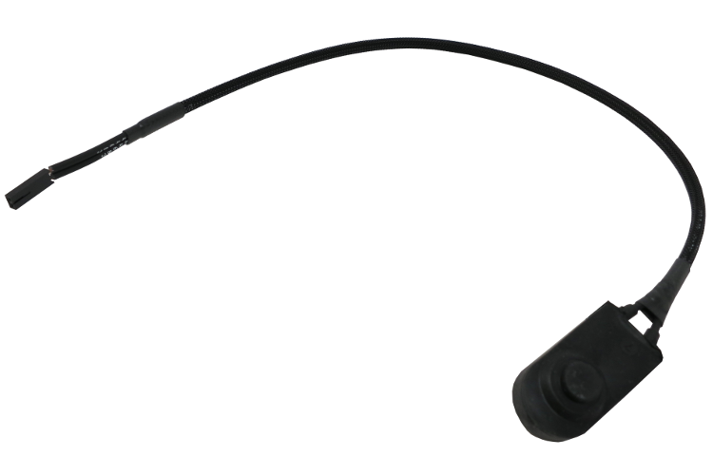

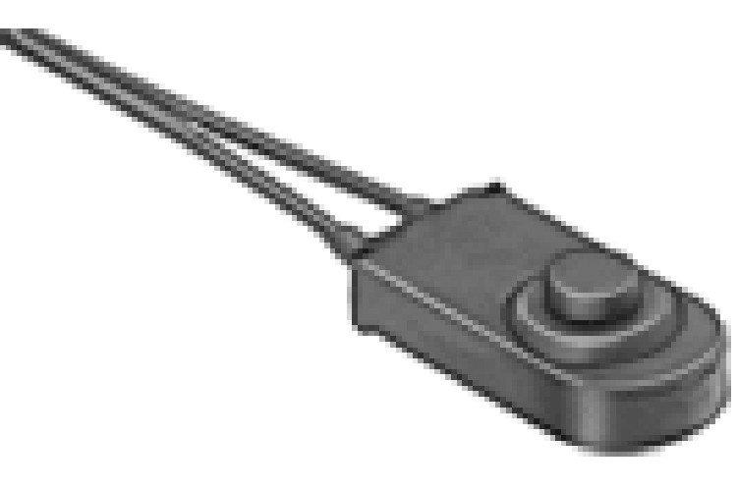

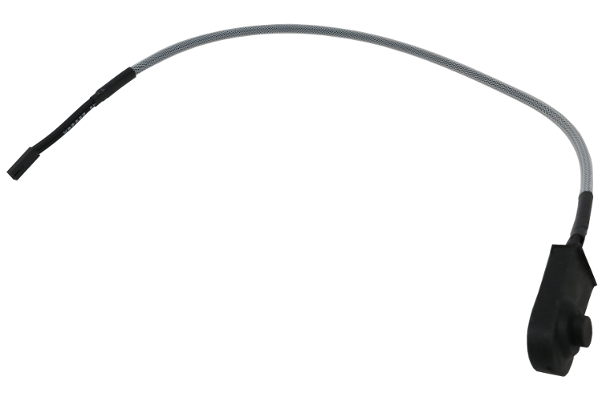

### Schematic

[./hardware/modular_device_remote_switch/schematic/modular_device_remote_switch.pdf](README.odt/hardware/modular_device_remote_switch/schematic/modular_device_remote_switch.pdf)

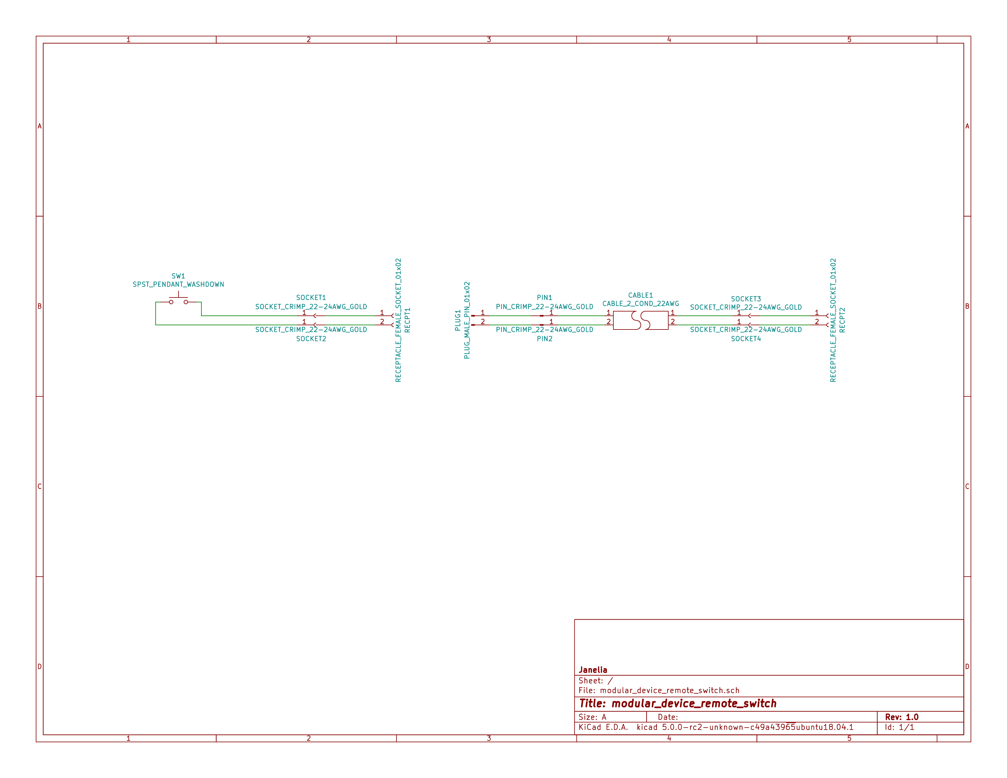

### Bill of Materials

1. PCB Parts

| Item | Reference(s) | Quantity | PartNumber | Vendor | Description |
| --- | --- | --- | --- | --- | --- |
| 1 | CABLE1 | 1 | A120-100-ND | digikey | MULTI-PAIR 2COND 22AWG 100FT |
| 2 | PIN1 PIN2 | 2 | WM2515-ND | digikey | CONN TERM MALE 22-24AWG GOLD |
| 3 | PLUG1 | 1 | WM2533-ND | digikey | CONN HOUSING MALE 2POS .100 |
| 4 | RECPT1 RECPT2 | 2 | WM2800-ND | digikey | CONN HOUSING 2POS .100 SINGLE |
| 5 | SOCKET1 SOCKET2 SOCKET3 SOCKET4 | 4 | WM2512-ND | digikey | CONN TERM FEMALE 22-24AWG GOLD |
| 6 | SW1 | 1 | 6944K11 | mcmaster | Pendant Switch Washdown Push Button |

1. Supplemental Parts

| Item | Quantity | PartNumber | Vendor | Description |
| --- | --- | --- | --- | --- |
| 1 | 1 | VFP014-1R0-ND | digikey | HEATSHRK VFP876 0.25 inch X 1 inch 50PCS |
| 2 | 1 | 1030-1001-ND | digikey | SLEEVING 0.125 inch X 225 feet BLACK |
| 3 | 1 | 1030-1333-ND | digikey | SLEEVING 0.125 inch X 225 feet RED |
| 4 | 1 | 1030-1332-ND | digikey | SLEEVING 0.125 inch X 225 feet PURPLE |
| 5 | 1 | 1030-1331-ND | digikey | SLEEVING 0.125 inch X 225 feet GREEN |
| 6 | 1 | 1030-1334-ND | digikey | SLEEVING 0.125 inch X 225 feet YELLOW |

1. Vendor Parts Lists

[./hardware/modular_device_remote_switch/bom/digikey_parts.csv](README.odt/hardware/modular_device_remote_switch/bom/digikey_parts.csv)

[./hardware/modular_device_remote_switch/bom/mcmaster_parts.csv](README.odt/hardware/modular_device_remote_switch/bom/mcmaster_parts.csv)

[./hardware/modular_device_remote_switch/bom/supplemental_digikey_parts.csv](README.odt/hardware/modular_device_remote_switch/bom/supplemental_digikey_parts.csv)

### Supplemental Documentation

1. Assembly Instructions
   * Choose 0.125 inch expandable sleeving color and cut to 18 inches.
   * Expand sleeving and slip over the two pendant switch wires, pushing it over the wires until the sleeve is within 0.5 inches from the switch.
   * Slip one 0.25 inch x 1 inch heat shrink tube over the wires and expanded sleeveing and push it as close to the switch as possible so it is covering one fraying end of the sleeving.
   * Slip another 0.25 inch x 1 inch heat shrink tube over the wires and expanded sleeving and push it until the center of the heat shrink tube is about 1.5 inches from the ends of the switch wires so it is covering the second fraying end of the sleeving.
   * Use a heat gun to shrink both heat shrink tubes on the sleeving and switch wires.
   * Use wire cutter to trim the two switch wires to the same length.
   * Use wire stripper to remove 0.1 inches of insulation from each of the two switch wires.
   * Use crimp tool to crimp one socket onto the end of each switch wire, using a total of two sockets.
   * Insert each of the two sockets into one receptacle connector, either wire can be placed into the pin 1 position, the placement position is not imporant.
   * Cut the 2-conductor cable to the desired length and remove 2 inches of the cable jacket from each of the two ends of the cable.
   * Slip a 0.25 inch x 1 inch heat shrink tube over each end of the cable jacket and use a heat gun to shrink it into place.
   * Use wire cutter to trim the two cable wires to the same length on each side of the cable.
   * Use wire stripper to remove 0.1 inches of insulation from each end of the two wires in the cable.
   * One one end of the cable, use crimp tool to crimp one socket onto the end of each the two cable wires, using a total of two sockets.
   * Insert each of the two sockets into one receptacle connector, either wire can be placed into the pin 1 position, the placement position is not imporant.
   * One the other end of the cable, use crimp tool to crimp one pin onto the end of each the two cable wires, using a total of two pins.
   * Insert each of the two pins into one plug connector, either wire can be placed into the pin 1 position, the placement position is not imporant.
   * Insert the receptacle connector attached to the switch into the plug connector on the cable.
   * Insert the receptacle connector attached to the cable into a two-pin BTN connector on the modular device.

## stepper_controller_5x3

### Repository Information

1. Name
   1. stepper_controller_5x3
2. Version
   1. 1.1
3. License
   1. Open-Source Hardware
4. URL
   1. <https://github.com/janelia-kicad/stepper_controller_5x3>
5. Author
   1. Peter Polidoro
6. Email
   1. peterpolidoro@gmail.com
7. Description

This board controls up to 3 stepper motors with optional forward and reverse limit switches for each motor.

### Images

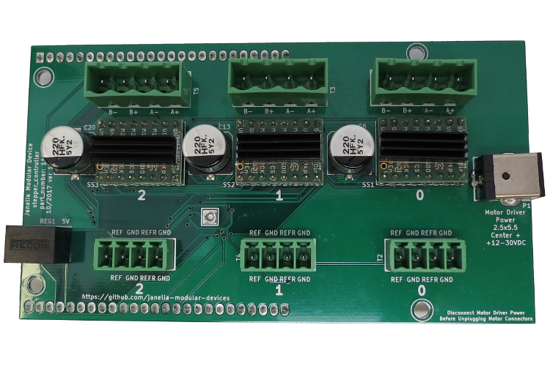

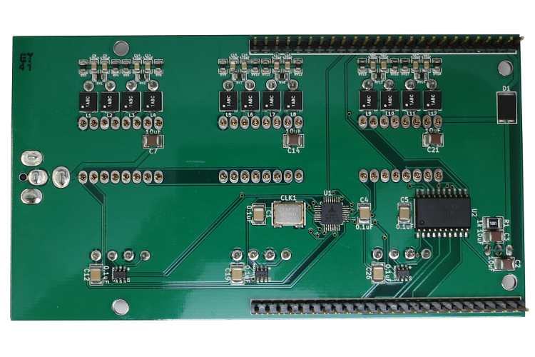

### Schematic

[./hardware/stepper_controller_5x3/schematic/stepper_controller_5x3.pdf](README.odt/hardware/stepper_controller_5x3/schematic/stepper_controller_5x3.pdf)

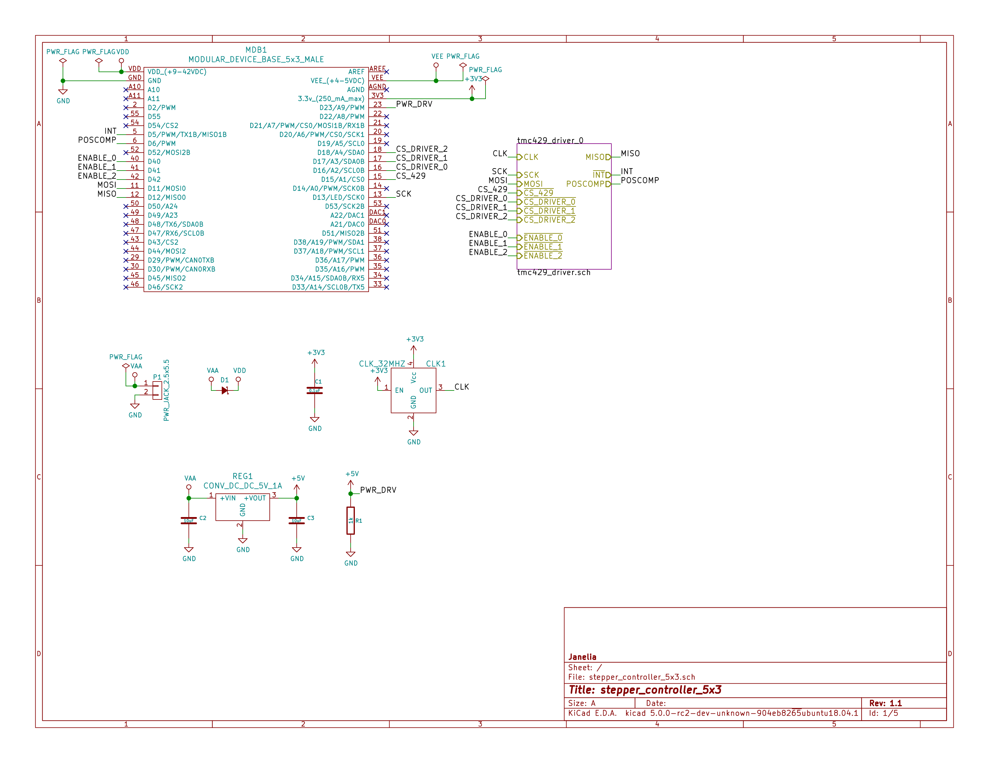

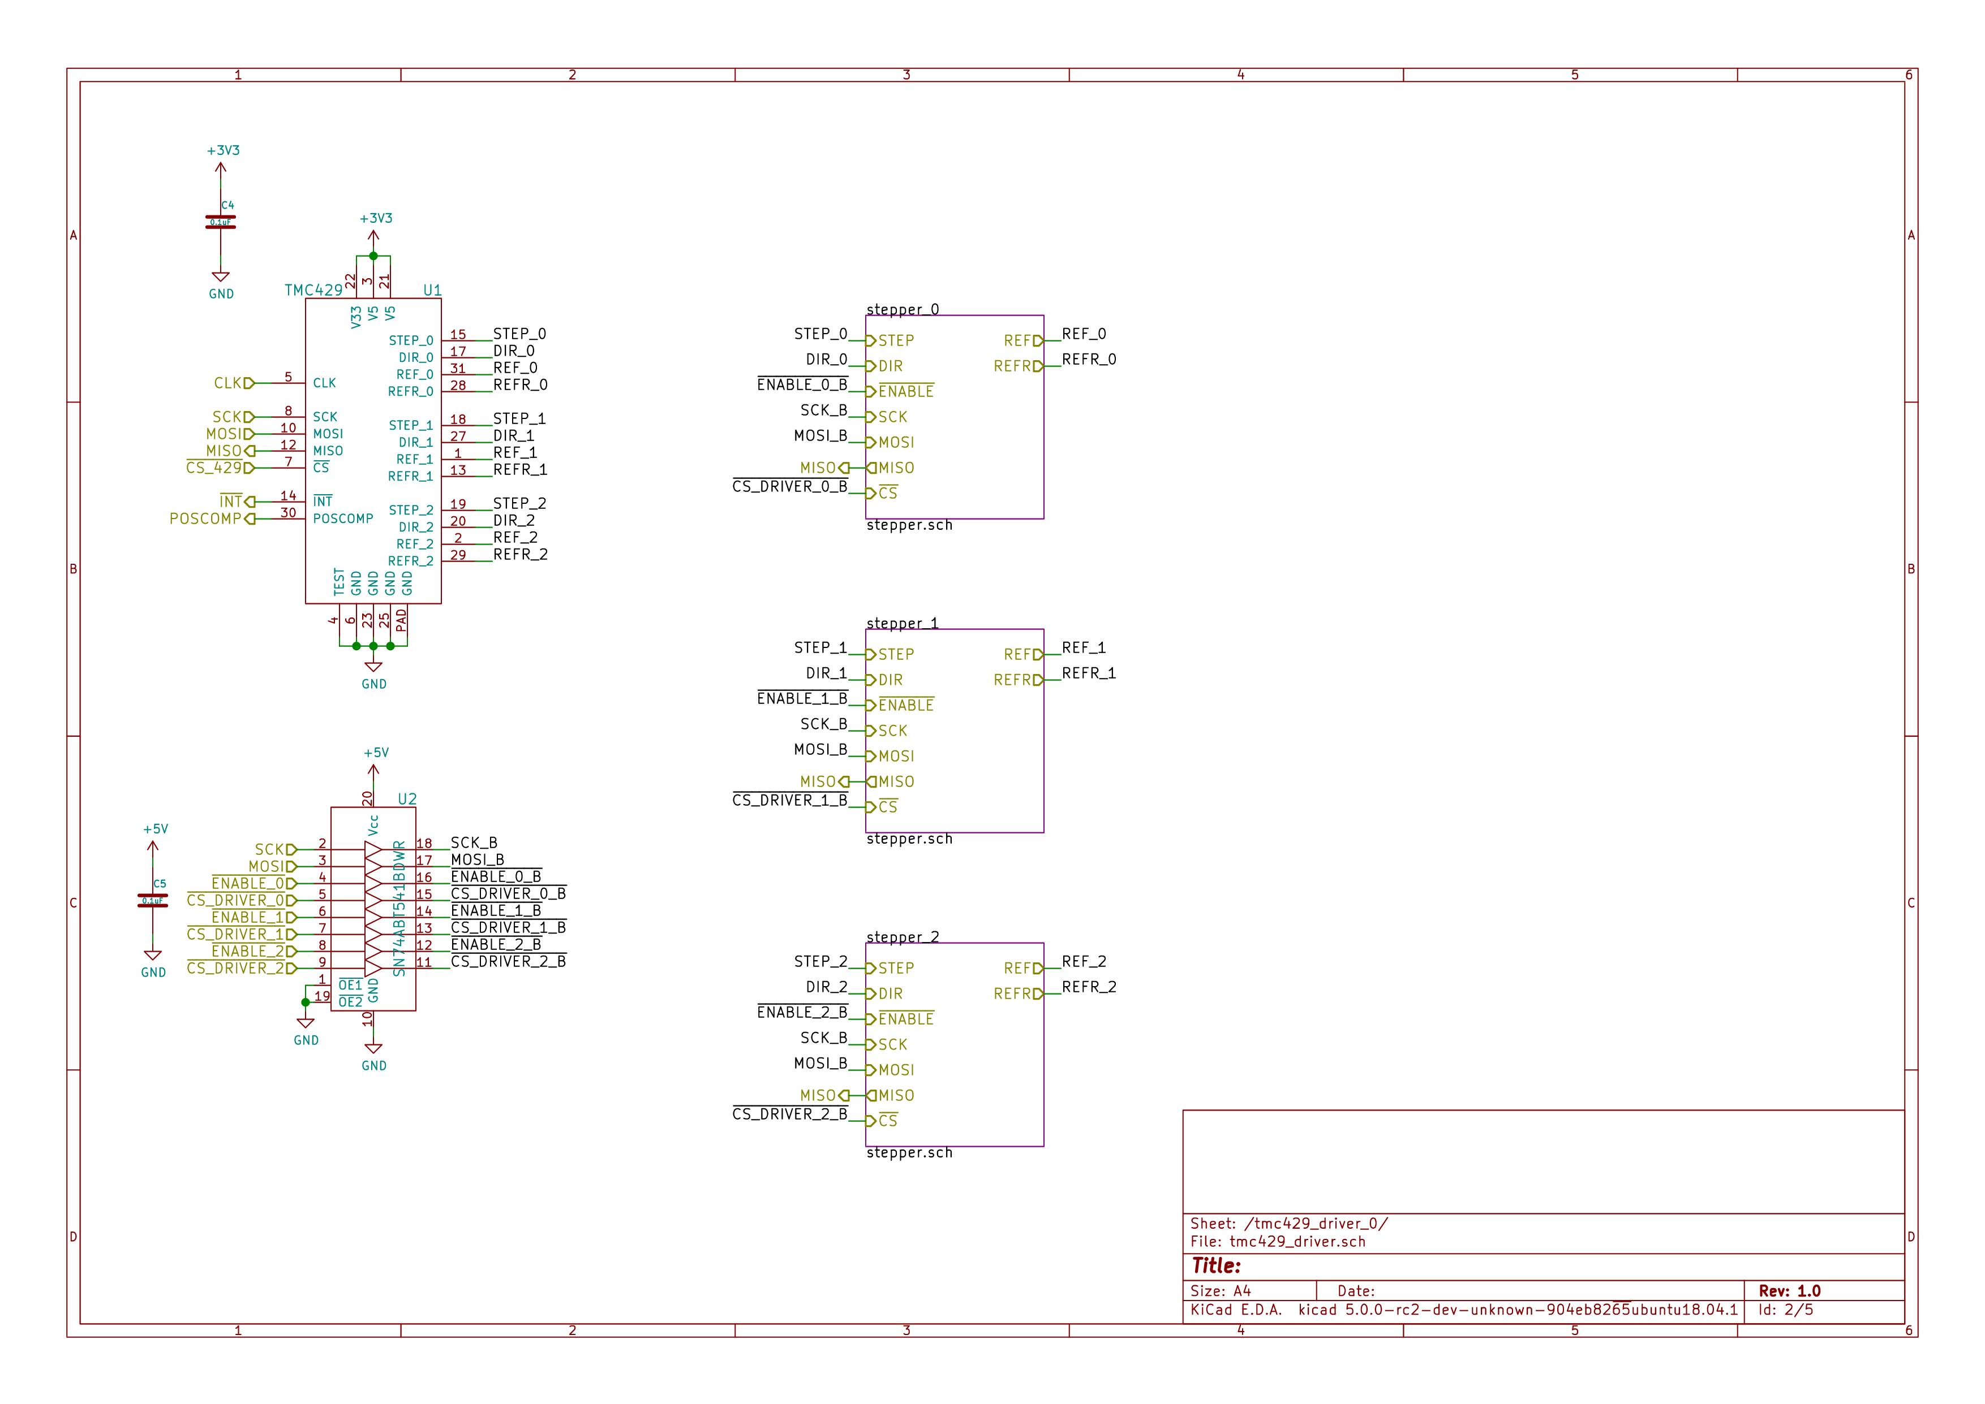

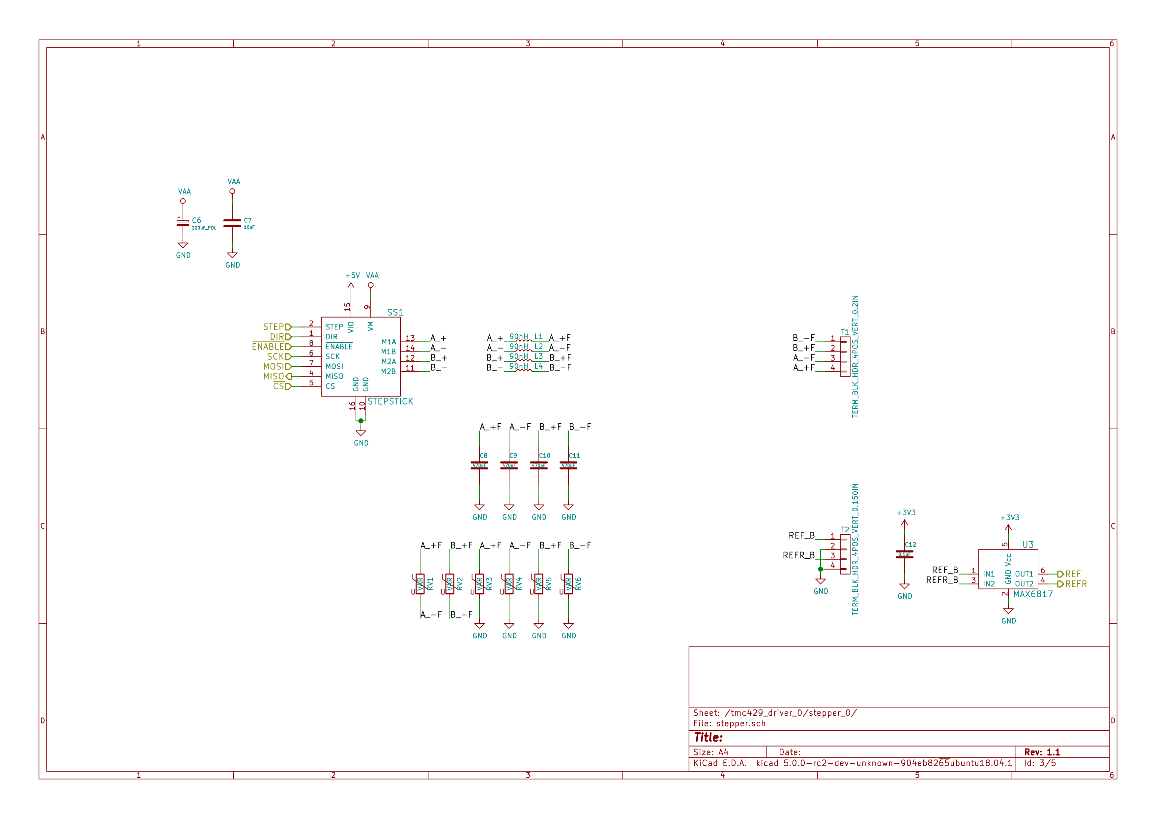

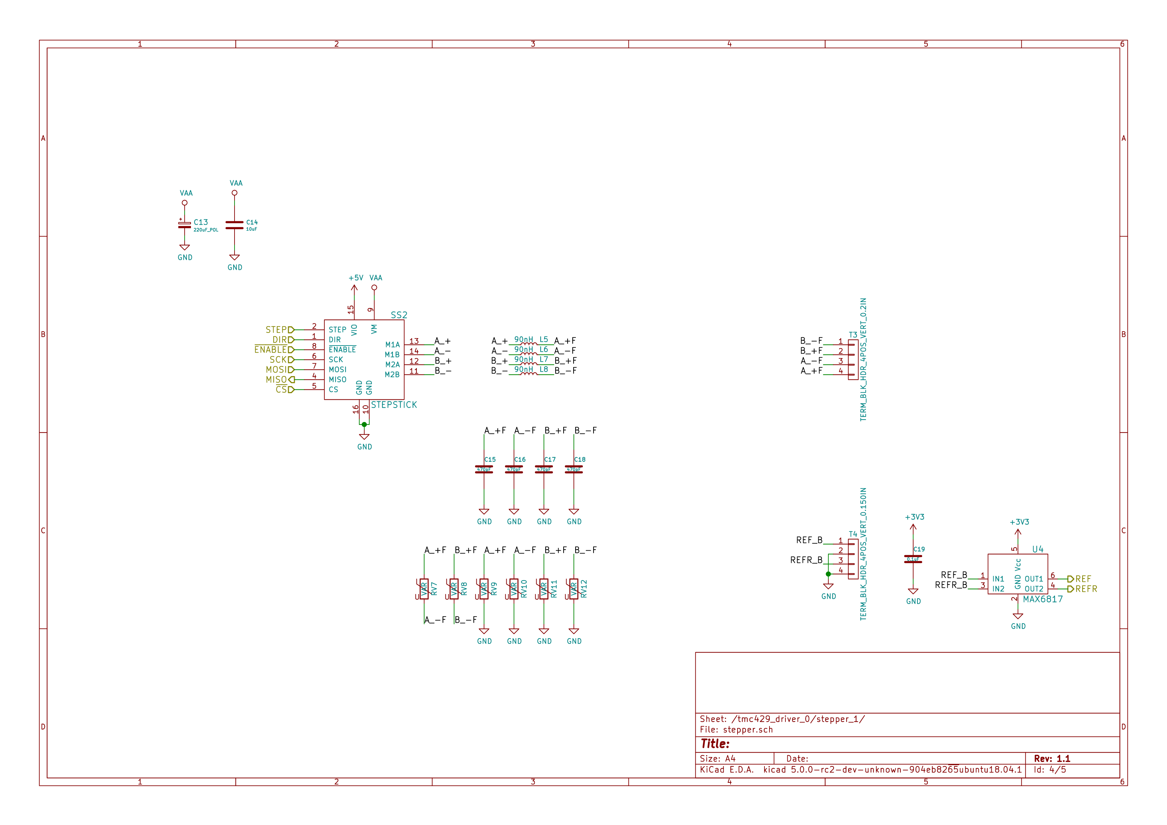

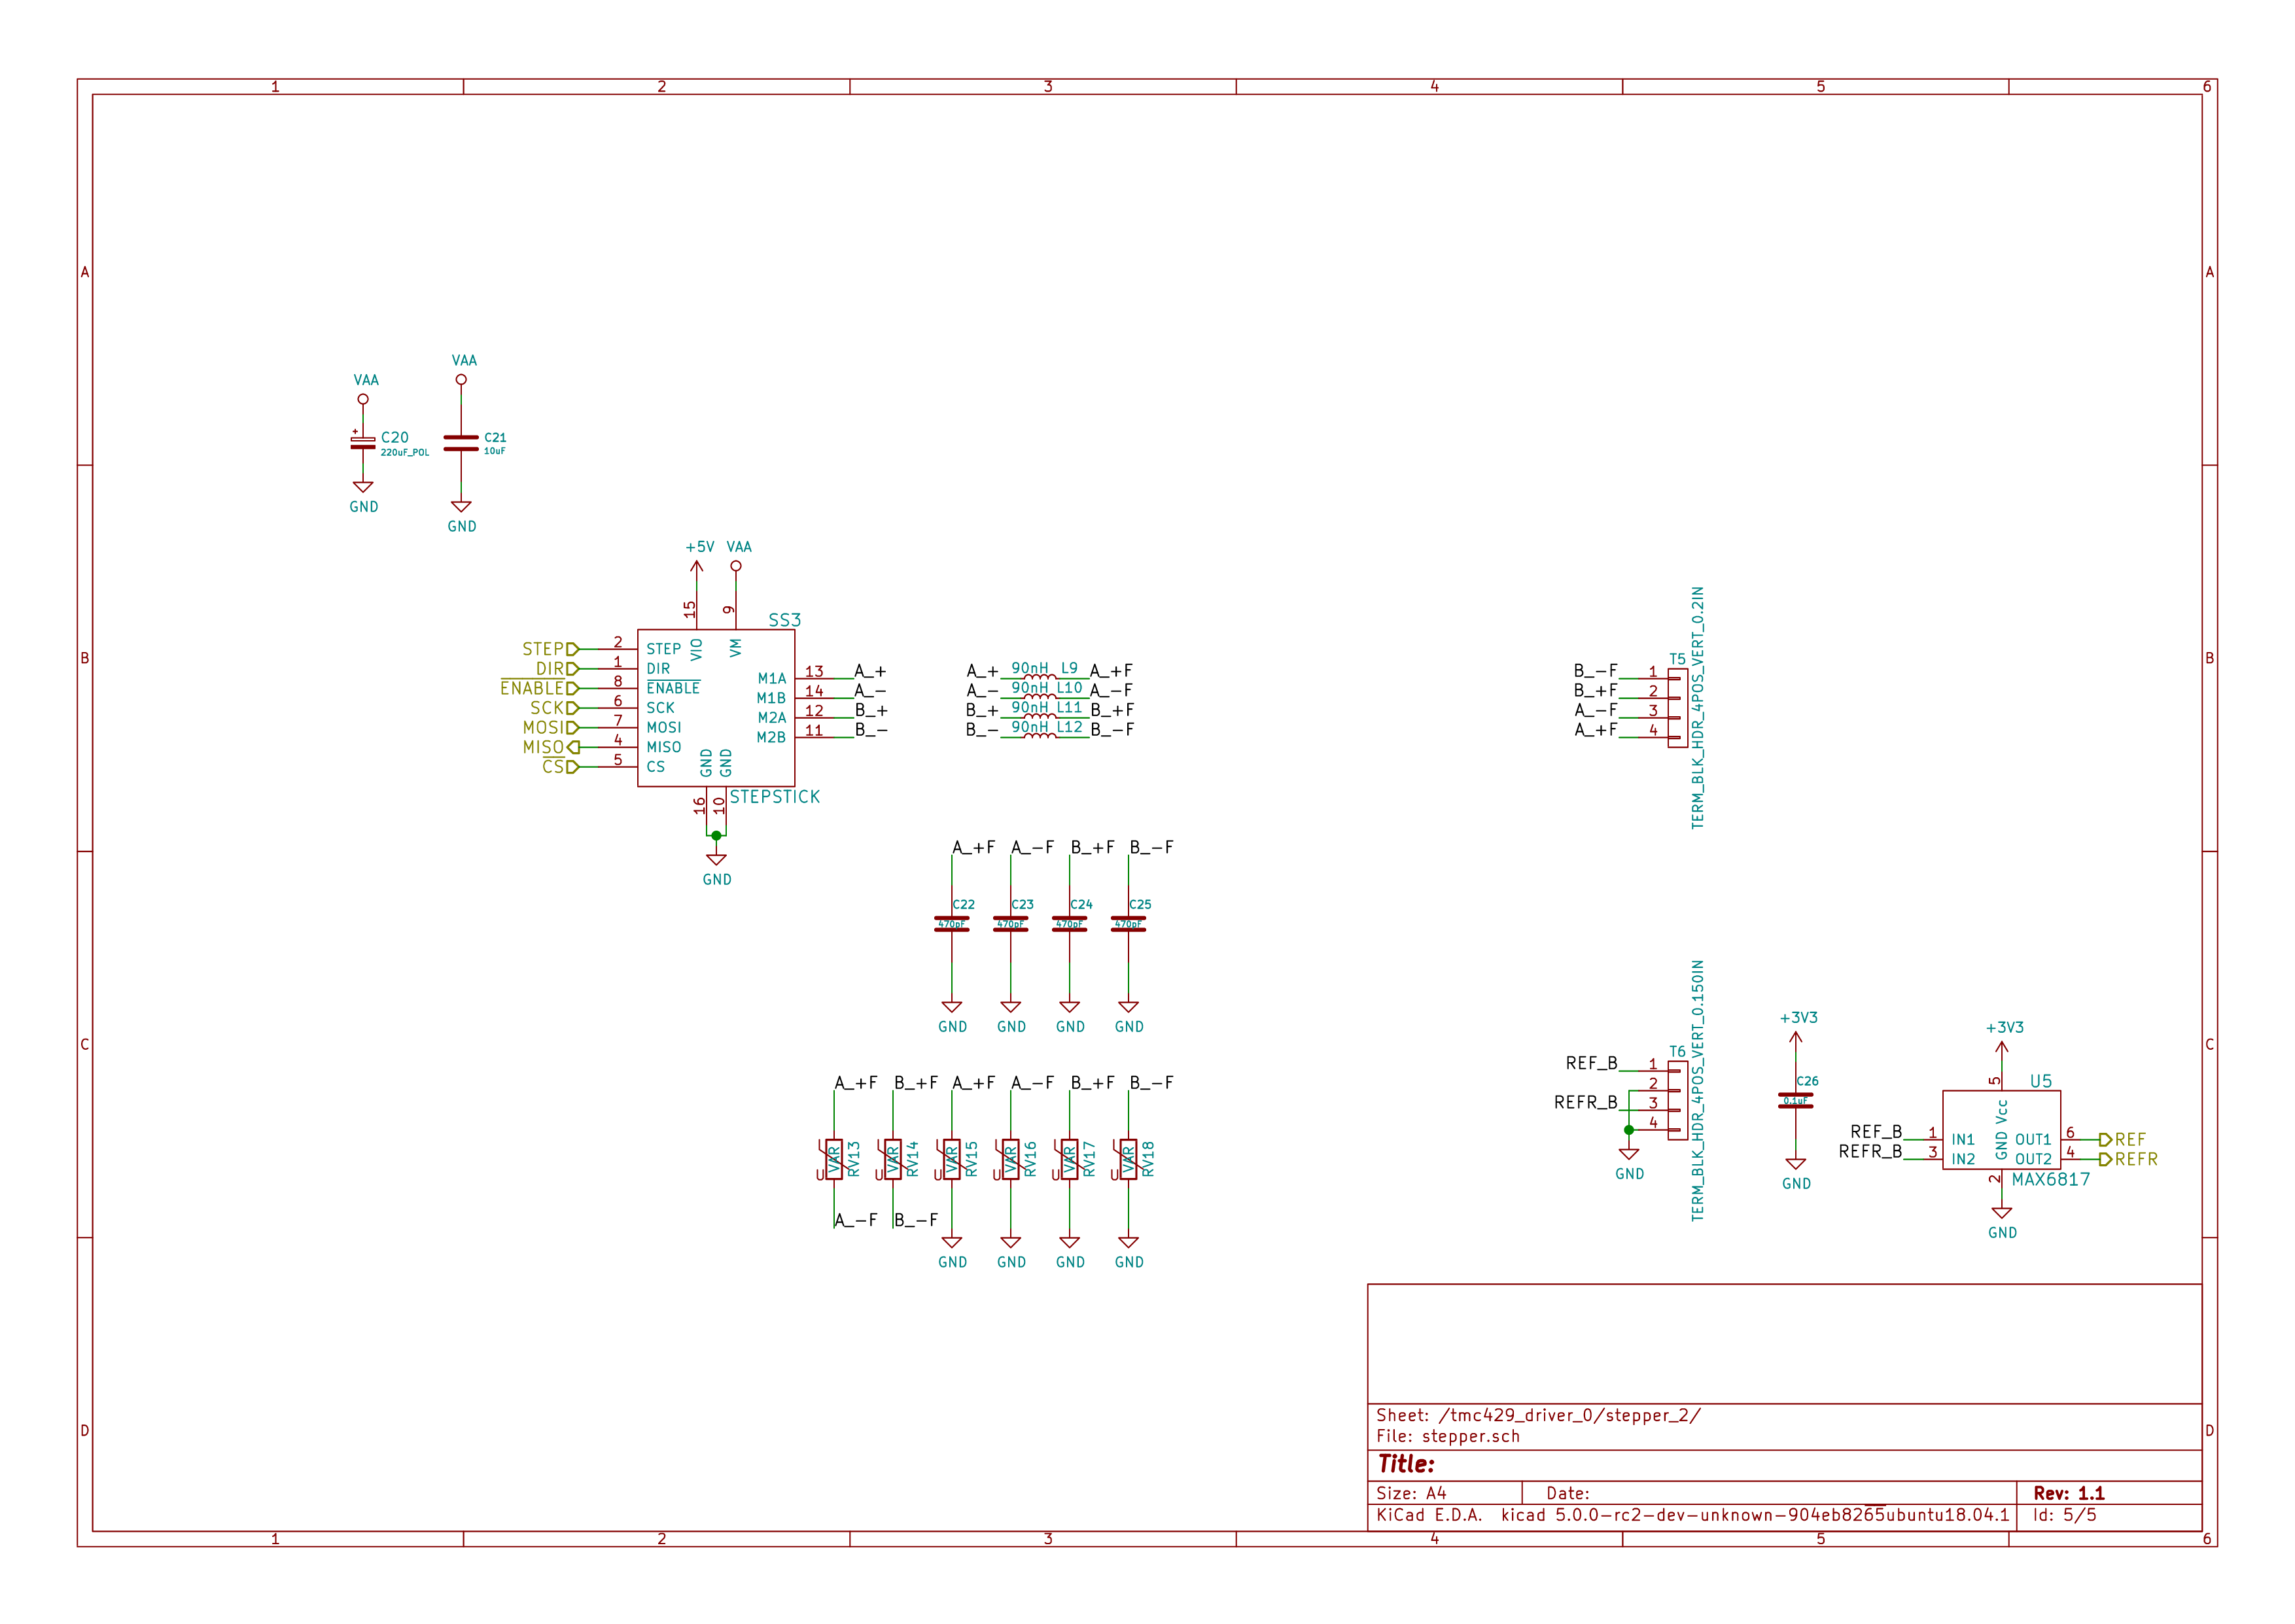

### Gerbers

Send gerbers zip file to your favorite PCB manufacturer for fabrication.

[./hardware/stepper_controller_5x3/gerbers/stepper_controller_5x3_v1.1.zip](README.odt/hardware/stepper_controller_5x3/gerbers/stepper_controller_5x3_v1.1.zip)

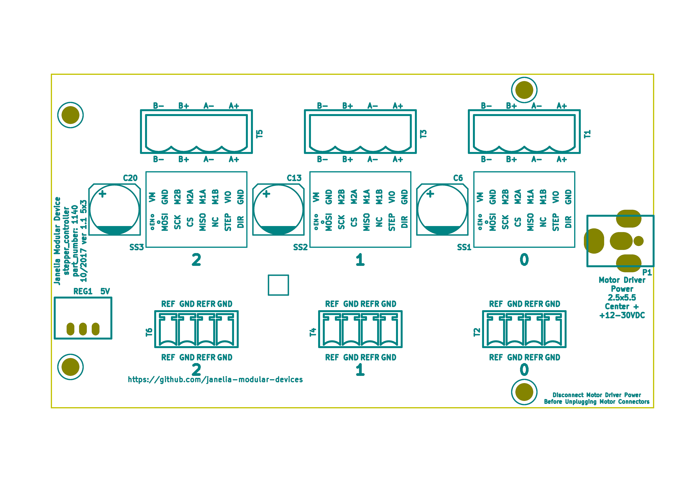

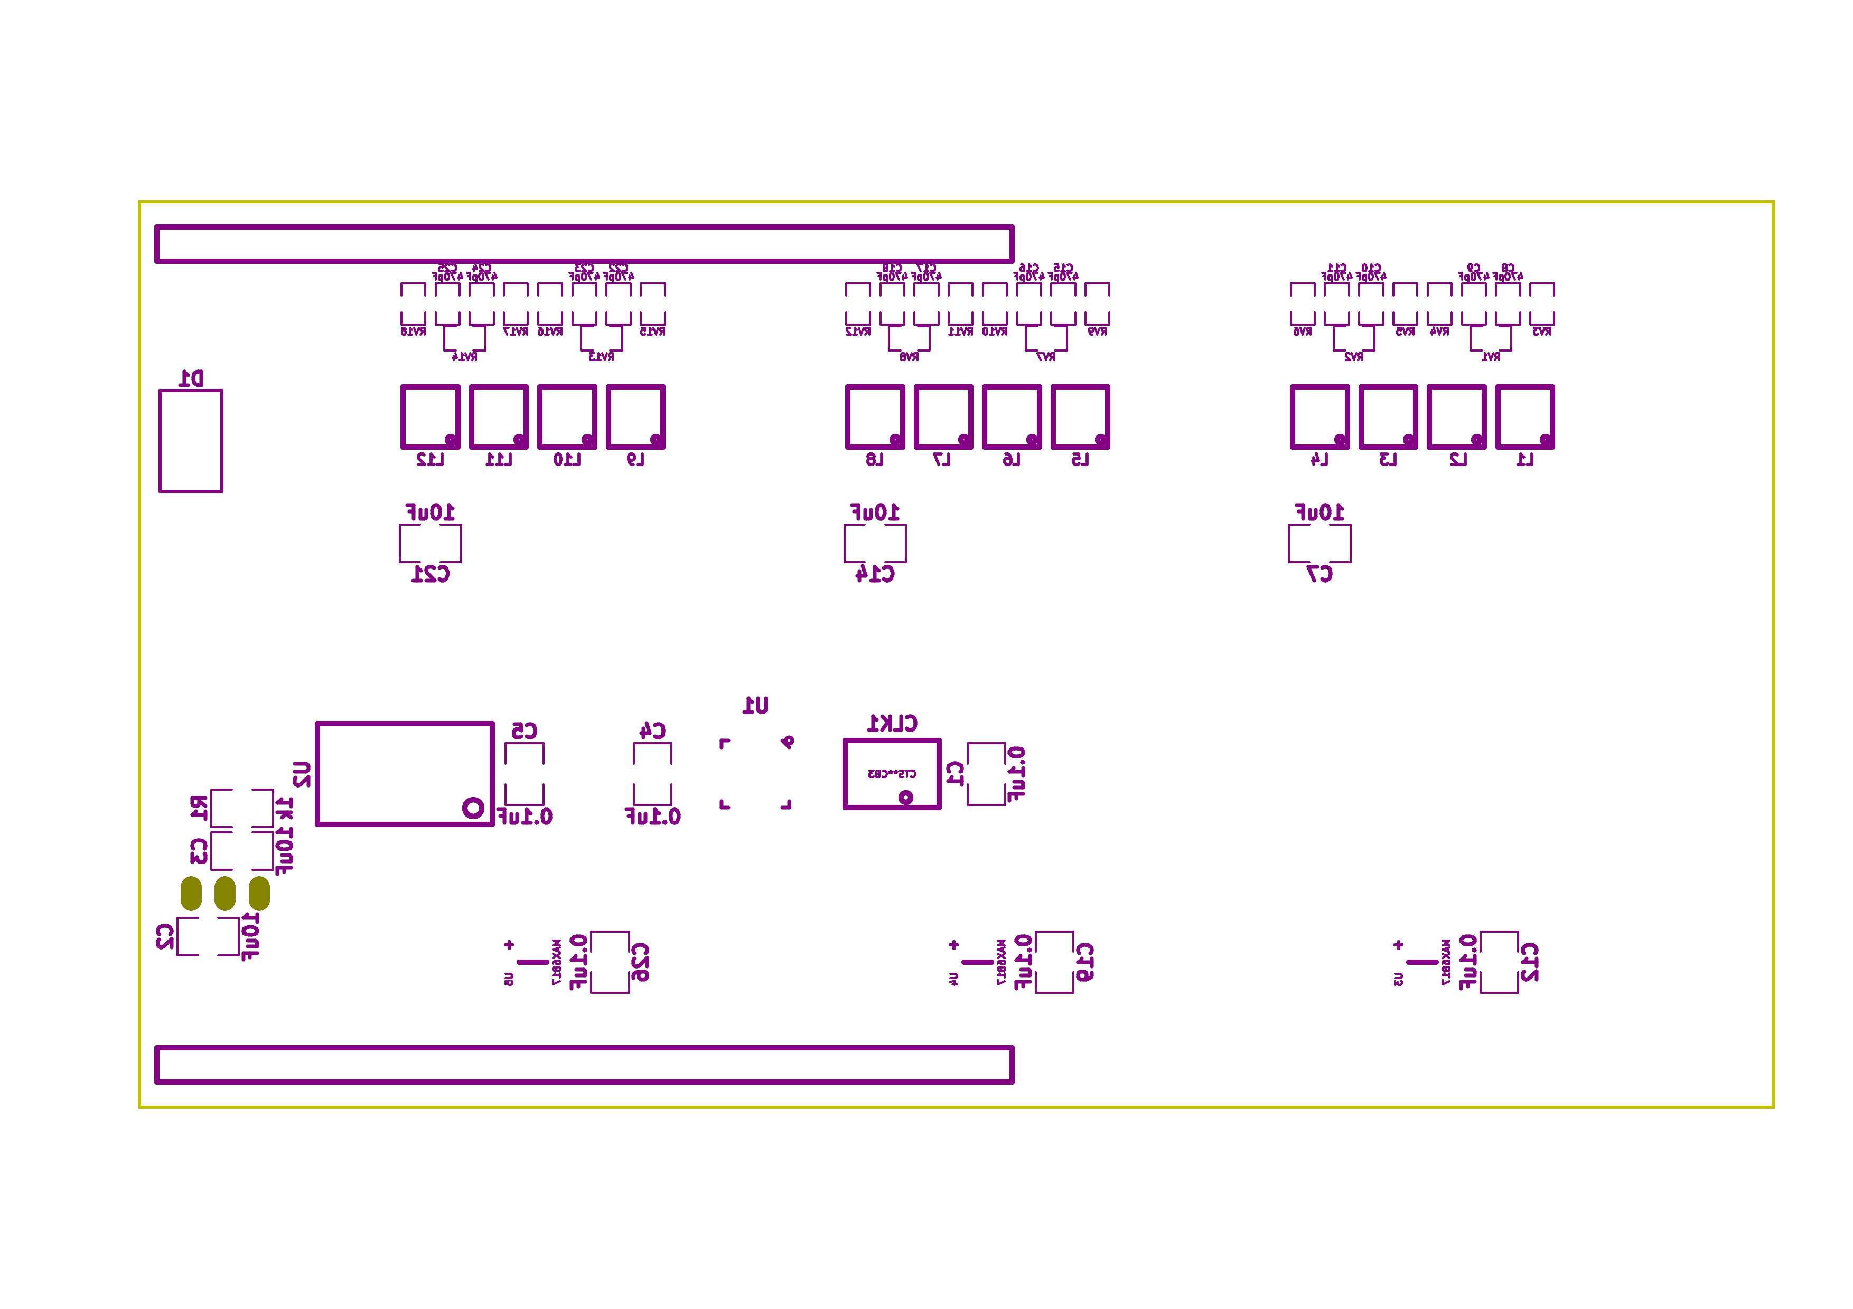

### Bill of Materials

1. PCB Parts

| Item | Reference(s) | Quantity | PartNumber | Vendor | Description |
| --- | --- | --- | --- | --- | --- |
| 1 | C1 C12 C19 C26 C4 C5 | 6 | 399-13229-1-ND | digikey | CAP CER 0.1UF 100V X7R 1210 |
| 2 | C10 C11 C15 C16 C17 C18 C22 C23 C24 C25 C8 C9 | 12 | 478-1350-1-ND | digikey | CAP CER 470PF 100V X7R 0805 |
| 3 | C13 C20 C6 | 3 | PCE3812CT-ND | digikey | CAP ALUM 220UF 20% 50V SMD |
| 4 | C14 C2 C21 C3 C7 | 5 | 445-4536-1-ND | digikey | CAP CER 10UF 50V 10% X7S 1210 |
| 5 | CLK1 | 1 | CTX277LVCT-ND | digikey | OSC XO 32.000MHZ HCMOS TTL SMD |
| 6 | D1 | 1 | 568-11697-1-ND | digikey | DIODE SCHOTTKY 45V 10A CFP15 |
| 7 | L1 L10 L11 L12 L2 L3 L4 L5 L6 L7 L8 L9 | 12 | XC2328CT-ND | digikey | FIXED IND 90NH 8A 8.5 MOHM SMD |
| 8 | MDB1 | 2 | S1011E-25-ND | digikey | 25 Positions Header Breakaway Connector 0.1in |
| 9 | P1 | 1 | CP-063BH-ND | digikey | CONN PWR JACK DC 2.5X5.5 8A T/H |
| 10 | R1 | 1 | P1.00KAACT-ND | digikey | RES SMD 1K OHM 1% 1/2W 1210 |
| 11 | REG1 | 1 | 945-1395-5-ND | digikey | CONV DC/DC 1A 5V OUT SIP VERT |
| 12 | RV1 RV10 RV11 RV12 RV13 RV14 RV15 RV16 RV17 RV18 RV2 RV3 RV4 RV5 RV6 RV7 RV8 RV9 | 18 | 495-7454-1-ND | digikey | VARISTOR 47V 80A 0805 |
| 13 | SS1 SS2 SS3 | 48 | ED90331-ND | digikey | CONN PIN RCPT .025-.037 SOLDER |
| 14 | T1 T3 T5 | 3 | 277-1152-ND | digikey | TERM BLOCK HDR 4POS VERT 5.08MM |
| 15 | T2 T4 T6 | 3 | 277-1223-ND | digikey | TERM BLOCK HDR 4POS VERT 3.81MM |
| 16 | U1 | 1 | 1460-1071-1-ND | digikey | IC MOTOR CONTROLLER SPI 32QFN |
| 17 | U2 | 1 | 296-14668-1-ND | digikey | Buffer Non-Inverting 1 Element 8 Bit per Element Push-Pull Output 20-SOIC |
| 18 | U3 U4 U5 | 3 | MAX6817EUT+TCT-ND | digikey | IC DEBOUNCER SWITCH DUAL SOT23-6 |

1. Supplemental Parts

| Item | Quantity | PartNumber | Vendor | Description |
| --- | --- | --- | --- | --- |
| 1 | 3 | 277-1013-ND | digikey | TERM BLOCK PLUG 4POS STR 5.08MM |
| 2 | 3 | 277-1042-ND | digikey | TERM BLOCK PLUG 4POS 5.08MM |
| 3 | 3 | 277-1163-ND | digikey | TERM BLOCK PLUG 4POS STR 3.81MM |
| 4 | 3 | 277-1193-ND | digikey | TERM BLOCK PLUG 4POS 90DEG 3.81MM |
| 5 | 3 | 1460-1187-ND | digikey | TMC2130 STEPPER DRIVER BOARD |
| 6 | 3 | 501100B00000G-ND | digikey | HEATSINK 14-DIP/16-DIP |
| 7 | 1 | 3M10315-ND | digikey | TAPE ADHESIVE TRANSFER 1/2in X5YD |

1. Vendor Parts Lists

[./hardware/stepper_controller_5x3/bom/digikey_parts.csv](README.odt/hardware/stepper_controller_5x3/bom/digikey_parts.csv)

[./hardware/stepper_controller_5x3/bom/supplemental_digikey_parts.csv](README.odt/hardware/stepper_controller_5x3/bom/supplemental_digikey_parts.csv)

### Supplemental Documentation

1. Assembly Instructions
   * Solder header pins into the stepper driver board(s), making note of TOP label. Insert header pins on bottom of board so that the long unsoldered header pins point down when the TOP label faces up.
   * Expose one side of the thermal adhesive tape and attach to the bottom of the heatsink. Trim tape so it does not extend beyond heatsink edges.
   * Expose the other side of the thermal adhesive tape and attach the heatsink to the stepper driver board on the side with the TOP label.
   * Solder surface mount and through hole components onto the pcb.
   * Insert stepper driver board(s) into pin receptacles.

# Firmware

## SpinningPlatformController

### Library Information

1. Name
   1. SpinningPlatformController
2. Version
   1. 2.0.0
3. License
   1. BSD
4. URL
   1. <https://github.com/janelia-arduino/SpinningPlatformController>
5. Author
   1. Peter Polidoro
6. Email
   1. peterpolidoro@gmail.com
7. Description

Modular device spinning platform controller library.

### API NAMES

{

"id": "getApi",

"result": {

"firmware": [

"SpinningPlatformController"

],

"verbosity": "NAMES",

"functions": [

"movePlatformSoftlyTo",

"getPlatformPosition",

"getPlatformTargetPosition",

"platformAtTargetPosition"

],

"parameters": [

"platform_position"

],

"properties": [

"platformPositionMin",

"platformPositionMax"

],

"callbacks": [

"incrementPlatformTargetPosition",

"decrementPlatformTargetPosition"

]

}

}

### API GENERAL

[./firmware/SpinningPlatformController/api/](README.odt/firmware/SpinningPlatformController/api/)

### Ancestors

<https://github.com/janelia-arduino/ModularServer>

<https://github.com/janelia-arduino/ModularDeviceBase>

<https://github.com/janelia-arduino/StepDirController>

<https://github.com/janelia-arduino/StepperController>

### Clients

### Devices

<https://github.com/janelia-modular-devices/modular_device_base.git>

<https://github.com/janelia-modular-devices/stepper_controller.git>

### More Detailed Modular Device Information

<https://github.com/janelia-modular-devices/modular-devices>

### Installation Instructions

<https://github.com/janelia-arduino/arduino-libraries>